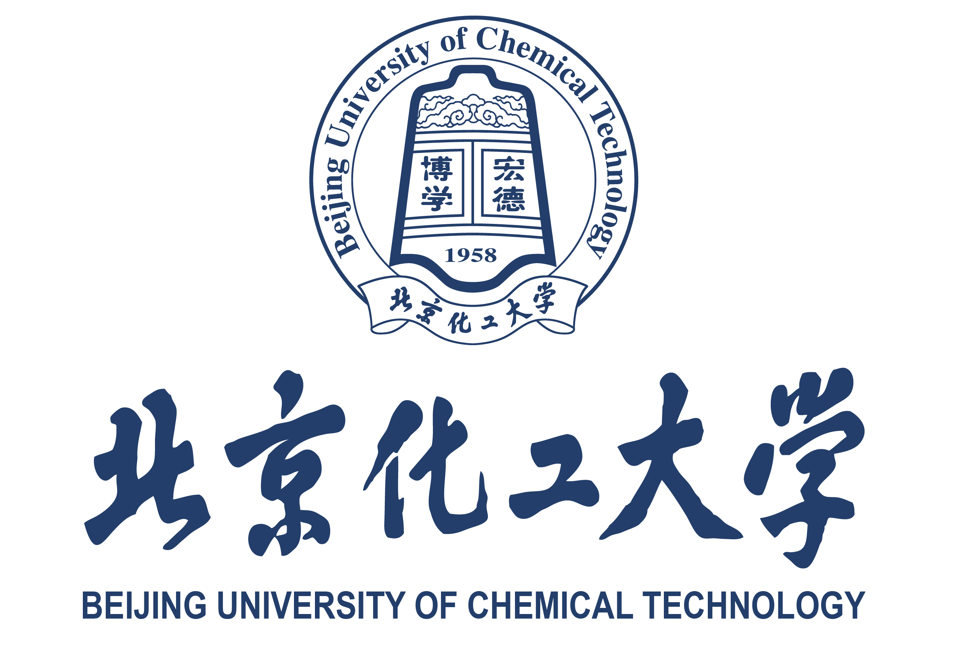

北京化工大学国际学生导师接收函
申请人基本信息/Basic Information of Applicant
姓名/Full Name |  |  |  | 国籍/Nationality |  |  |  |  | 性别/Gender
护照号码/Passport No. |  |  |  | 联系邮箱/Email
研究生导师基本意见/Acceptance by Supervisor
研究生导师姓名（中文） |  |  |  |  | 所属学院/Faculty
联系电话/Contact Phone Number |  |  |  |  | 联系邮箱/ Email
导师评价/Supervisor's Assessment Record:
备注：建议导师通过电话、视频等方式对学生进行面试，评价可包含学术背景、科研能力和学习态度等方面的内容。
Dear [Student’s Name],

I am pleased to issue this letter confirming my intention to accept you as a [Master / PhD] student in the [Major/Program Name] at Beijing University of Chemical Technology (BUCT). Your program is scheduled to begin on September 1, 20XX, and is expected to be completed by July 15, 20XX. The language of instruction for your program will be [English / Chinese].

After your registration, I would like to welcome you join my research group in the College of [XXXXXX], where you will undertake research in the area of [brief research direction]. Our research center is well equipped with advanced facilities that will strongly support your academic and research development. Based on your academic background and the qualifications presented in your previous degree, I believe you have demonstrated strong potential for graduate-level study and research. I also believe that the research training and academic environment at BUCT will be highly beneficial for your future career development.

Please carefully review the application requirements on the website of the International Office of BUCT and ensure that all necessary materials are submitted before the deadline. You are strongly encouraged to apply for the Chinese Government Scholarship, which is a prerequisite for final admission.

Should you have any questions regarding this acceptance letter or the application process, please feel free to contact me. I look forward to welcoming you to my research group at BUCT.

Sincerely,
导师签名/Supervisor’s Signature |  |  |  |  |  | 日期/Date
备注/Note：本接收函不代表最终录取结果。申请者可持本函及申请资料向北京化工大学国际教育学院留学生办公室提交正式申请。This letter does not represent the final admission result. Applicants may submit this letter along with their application materials to the International Student Admissions Office of BUCT.
联系我们/Contact us：International Student Office , BUCT
Phone: 0086-10-64452461 Email：buctapply@buct.edu.cn Website：https://english.buct.edu.cn
Acceptance Letter for International Student

