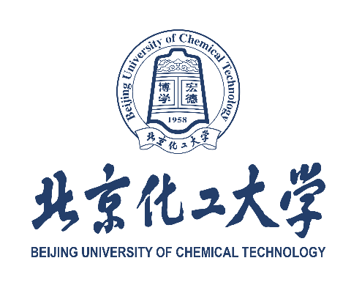

北京化工大学申请攻读硕士/博士研究生个人陈述
BUCT Personal Statement for Graduate Application
护照姓名Applicant’s Passport Name:
申请学院Department/College/School of Interest:
申请专业Major of Interest:
请从学术背景、与申请专业有关的研究工作经历及成果、攻读研究生阶段的学习和研究计划以及毕业后的发展目标等几个方面进行陈述，用中文或英文撰写。
Please describe your academic background, research experience, achievements, and future study or career plans.
个人声明（必填项）Declaration (*Required)
请回答：你是否同时拥有中国香港、中国澳门或中国台湾地区的身份证件或身份证明？（请在下方填写是或否）
Please reply: Are you currently holding the resident identity card of Hong Kong, Macau or Taiwan? (Yes or No)

注：持有上述身份证件或证明的申请人，不可作为外国留学生申请我校。
NOTE: Applicants holding a resident identity card of Hong Kong, Macau, or Taiwan are ineligible to apply to Beijing University of Chemical Technology (BUCT) as international students.

我承诺个人陈述中的信息真实准确，由我本人独立完成。我知晓如有虚假不实信息，将被北京化工大学取消申请、录取及入学资格。
I hereby confirm that all the information provided above is true, accurate, and completed by myself. I understand that any false or misleading information may result in the cancellation of my application, admission, or enrollment at Beijing University of Chemical Technology (BUCT).

签名（手写签名）Signature (handwritten): ________________________日期 Date: ________________

