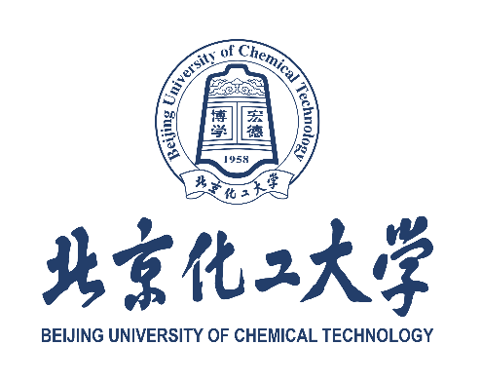

Degree Authentication Requirement for International Applicants

Note: This document is provided as a sample for applicants to BUCT. Please obtain the actual authentication report from CSCSE (for overseas degrees) or CHSI (for Chinese degrees) before submission.
在境外高校获学位证书的申请者原则上须提交中国教育部留学服务中心的学位认证报告。
The degree diploma awarded by overseas universities should be authenticated by Chinese Service Center for Scholarly Exchange, Ministry of Education, P.R. China（CSCSE）: http://zwfw.cscse.edu.cn/

在中国境内高校获学位证书的申请者原则上须提供中国高等教育学生信息网（学信网）出具的学位认证报告。以下三种认证报告，任意一种皆可。
The degree diploma awarded by universities of Chinese mainland should be authenticated by Center for Student Services and Development, Ministry of Education, P.R. China（CSSD）https://www.chsi.com.cn/en/. Any one of the following 3 certification reports is acceptable.

