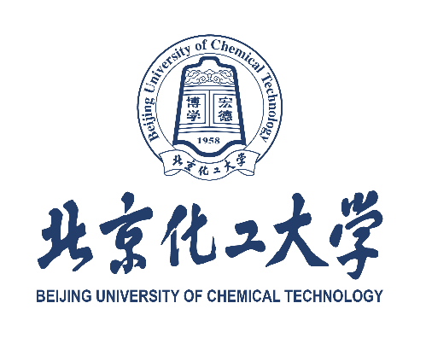

北京化工大学申请人推荐信
RECOMMENDATION FOR APPLICANT OF BEIJING UNIVERSITY OF CHEMICAL TECHNOLOGY

申请人护照姓名Applicant’s Passport Name: ______________________________________
申请专业Prospective Major: _____________________________________________________

推荐人姓名Recommender’s Name: _______________________________________________
单位Organization: _____________________________________________________________
职务Occupation: ______________________________________________________________
电话Tel: _________________________ 电子邮件E-mail: _________________________

1. 推荐人与申请人的关系 What is your relationship to the applicant?

□ 授课教师/导师 | □ 所在学校/留学院行政人员 | □ 其他
Teacher/Supervisor | Administrator of School/Institution | Others

如果是“其他”关系，请说明

If others, please indicate ____________________________________________________________
2. 推荐人认识申请人的时间 How long have you known the applicant?

□ 不足一年 | □ 一年至三年 | □ 三年以上
Less than one year | One year to three years | More than three years

3. 请推荐人为申请人的以下情况进行评价 Please evaluate how the applicant ranks in the following aspects.

A – 卓越 | B – 满意 | C – 需要改进 |  | D – 不满意 |  | O – 无法评价
Outstanding | Satisfactory | Needs Improvement |  | Unsatisfactory |  | Unable to Evaluate
 | 评价内容 |  |  |  | A | B |  | C | D | O
Aspects to Be Evaluated |  |  |  |  | A | B |  | C | D | O
个人道德品质 |  |  |  |  | □ | □ |  | □ | □ | □
 | Moral Quality |  |  |  | □ | □ |  | □ | □ | □
 | 学习动力 |  |  |  | □ | □ |  | □ | □ | □
 | Motivation |  |  |  | □ | □ |  | □ | □ | □
独立学习能力 |  |  |  |  | □ | □ |  | □ | □ | □
Capability of Independent Study |  |  |  |  | □ | □ |  | □ | □ | □
 |  |  | 口头表达 |  | □ | □ |  | □ | □ | □
英语语言水平 |  |  | Oral |  | □ | □ |  | □ | □ | □
English Language Skills |  |  | 书面表达 |  | □ | □ |  | □ | □ | □
 |  |  | Written |  | □ | □ |  | □ | □ | □
人际交往能力 |  |  |  |  | □ | □ |  | □ | □ | □
Skills of Communicating with Others |  |  |  |  | □ | □ |  | □ | □ | □
 | 适应能力 |  |  |  | □ | □ |  | □ | □ | □
 | Adaptability |  |  |  | □ | □ |  | □ | □ | □
 | 心理素质 |  |  |  | □ | □ |  | □ | □ | □
Quality of Mind, Reaction on Stress |  |  |  |  | □ | □ |  | □ | □ | □

5. 对申请人的其他评价 Additional Comments on the Applicant
请从品德修养、知识结构、科研能力、工作成果、培养潜力等几个方面对申请人进行推荐
Please recommend the candidate on his/her personality, academic knowledge, research ability, and potential for graduate study at Beijing University of Chemical Technology (BUCT).

推荐人声明，以上信息在本人/本机构所知悉的范围内均真实准确，并同意接受北京化工大学的联系及根据需要对申请人的情况进行补充说明。

I, the undersigned individual or the authorized representative by the stamped institution, hereby confirm that all the comments above are accurate to the best of my or the institution’s knowledge. And I would like to make additional comments beyond those I have provided upon the requirement of Beijing University of Chemical Technology.

推荐人签名Recommender’s Signature (handwritten): ______________________ 日期Date: ________________________

