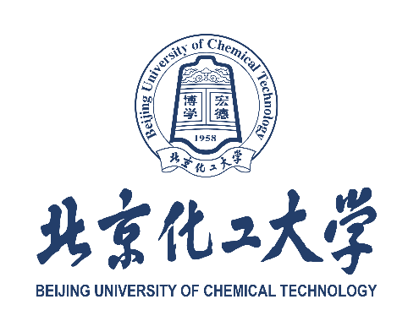

诚信承诺书
Integrity Commitment Letter
承诺人姓名（与护照一致） / Full Name (As in Passport): ___________________________
身份证件类型及号码 / Type & No. of Identity Document: ___________________________

本人郑重承诺如下事项：
I hereby make the following solemn commitment:
1.本人已认真核对所提交的所有申请材料（包括书面和电子版），并确认所有信息、材料和文件均真实、准确、有效。
I have carefully reviewed all the application materials, both in printed and electronic forms, and confirm that all the information, materials, and documents I submitted are true, accurate, and valid.
2.本人对在申请过程中由北京化工大学及相关部门进行的材料真实性审核结果承担全部责任。
I take full responsibility for the results of the authenticity verification of my application materials conducted by Beijing University of Chemical Technology and relevant departments.
3.本人明白，若提交虚假、伪造或编造的材料，属于严重违规行为；本人接受在此情况下立即被取消申请资格、录取资格及相关处罚。
I understand that submitting false, fabricated, or forged materials constitutes a serious violation, and I accept that under such circumstances, my application, admission, or registration will be immediately canceled, along with any related penalties.

承诺人签名 / Signature (handwritten): ______________________________________
日期 / Date: _______________________________

